# Sprint Review and Sprint Retrospective I - GOATs

* Features implemented
  + Completed Software Requirements Specification (SRS) sections, including:
    - Introduction, Description, Functional and Nonfunctional Requirements, and Review
  + Created GitHub project build environment
  + Introduced teammates to Expo usage
  + Developed and integrated UI mockups into SRS
  + Conducted Sprint Review 1
  + Completed peer reviews for multiple team members
  + Updated user stories and project description based on feedback
  + Added shared drive link to GitHub README
* Issues fixed
  + Improved clarity in software requirements specification
  + Integrated team feedback into project documents
  + Resolved inconsistencies in user stories
* Implementation review
  + *What went well in the implementation*
    - Efficient collaboration in completing SRS with all team members doing their part well and in appropriate time
    - Successful setup and education of GitHub project build environment across teammates
    - Timely completion of peer review report submission
  + *What problems occurred*
    - Some delays in introducing teammates to Expo usage
    - Initial inconsistencies in user stories and project description
    - Misalignment of some UI mockups with the requirements
  + *How problems were solved*
    - Held quick knowledge-sharing sessions for Expo onboarding
    - Incorporated feedback to refine user stories and project description
    - Adjusted UI mockups to better align with project requirements
* Changes made
  + Standardized formatting across the SRS
  + Improved clarity in user stories based on feedback
  + Updated the README with a shared drive link and problem statement
  + Refined UI mockups to match functional requirements
* Plans for next sprint *(What will be done for the next sprint)*

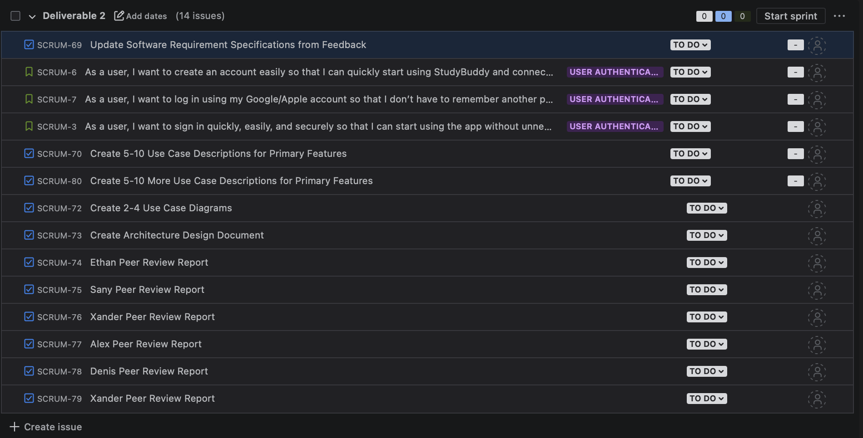

* Sprint Retrospective
  + *What went well?*
    - Everybody got everything they needed to get done, and when all tasks were completed the full scope of the deliverable was done.
  + *What could be improved?*
    - Work could be broken up a bit more evenly. It didn’t create a problem this time, but some people definitely had more work than others.
  + *What will we commit to improve in the next Sprint?*
    - *What changes will be made to how we work for the next sprint?*
      * *Consider the difficulty level of tasks more significantly than number of tasks (use story points!)*

| *Change* | *Who will be responsible for the change* | *Who will check in on the change half-way and when* |
| --- | --- | --- |
| *Implement/make more effective use of story points* | *Ethan Morin* | *Collective goal to check* |
|  |  |  |
|  |  |  |

| Challenge | Potential ways to address the challenge |
| --- | --- |
| Alex - Learning how to use Firebase | Plenty of YouTube videos covering the basics of using Firebase with react native |
| Alex - Potentially learning Go for back end development | The hope is that we won’t need a back end and that firebase will cover it, but should we need to we want to use Go for this. |
| Noah - Framing the wireframe to fit new ideas and new formatting | Pre-plan ahead with the team. Get a general idea before doing anything |
| Xander - Learning HTML and Go | Taking things slowly and taking notes and making sure I'm retaining information and also practicing using both languages. Read textbook as well |
| Ethan - More thoroughly document what we discuss in each meeting | Make sure I remember to take meeting notes each week. |
|  |  |